

Project Report
Project: Network Automation with Ansible
University of Information Technology – UIT

Submitted by:
Trần Ngọc Bá Duy Student ID: 24560039

Instructor:
Ms. Trần Thị Dung

Due Date: 24/08/2025

Table of Contents
Table of figures 3
Abbreviation 4
- INTRODUCTION 5
  - Definition 5
  - Components 5
  - Operation 8
- IMPLEMENTATION 9
  - Topology 9
    - Basic scenario 9
    - Advanced scenario 11
  - Installation 13
    - GNS3 installation 13
    - Ansible installation 14
  - Configuration 16
    - GNS3 configuration 16
    - Ansible configuration 17
- RESULT 19
  - Basic scenario 19
  - Advanced scenario 23
- REFERENCES 28

Table of figures
Figure 1. Basic Scenario Topology 10
Figure 2. Advanced Scenario Topology 12
Figure 3. GNS3 package installation 13
Figure 4. GNS3 preferences 13
Figure 5. GNS3 VM 14
Figure 6. Ansible version 15
Figure 7. Firewall status 15
Figure 8. SSH configuration 15
Figure 9. GNS3 GUI 16
Figure 10. Basic inventory 17
Figure 11. Basic config 17
Figure 12. Advanced inventory 17
Figure 13. Advanced inventory 18
Figure 14. R1 configuration 19
Figure 15. R2 configuration 20
Figure 16. R3 configuration 21
Figure 17. Test connectivity 22
Figure 18. Run basic playbook 22
Figure 19. Advanced R1 configuration 23
Figure 20. Advanced R2 configuration 24
Figure 21. Advanced R3 configuration 25
Figure 22. PC1 ping to PC2 26
Figure 23. PC2 ping to PC3 26
Figure 24. PC3 ping to PC1 27

Abbreviation:
- APT: Advanced Package
- ufw: Uncomplicated Firewall
- VM: Virtual Machine
- YALM: Yet Another Markup Language
- EVE-NG: Emulated Virtual Environment - Next Generation
- GNS3: Graphical Network Simulator-3
- DHCP: Dynamic Host Configuration Protocol
- NAT: Network addres translation
- VPC: Virtual PC

INTRODUCTION
Network automation has become essential in modern IT infrastructure management, enabling administrators to configure, manage, and maintain network devices efficiently and consistently. This project explores the implementation of network automation using GNS3 (Graphical Network Simulator 3) and Ansible, demonstrating how these tools can streamline network operations and reduce human error in network configuration tasks.
Traditional network management involves manual configuration of individual devices, which is time- consuming, error-prone, and difficult to scale. Network automation addresses these challenges by providing programmatic control over network infrastructure, enabling rapid deployment, consistent configuration, and centralized management of network devices.

Definition
GNS3 (Graphical Network Simulator 3) is an advanced open-source network emulator that allows engineers to create, test, and troubleshoot complex topologies without physical hardware. Unlike lightweight simulators such as Cisco Packet Tracer, GNS3 is capable of emulating real Cisco IOS images and integrating with other open-source and commercial appliances. It provides a realistic environment for practicing certification labs, validating network designs, and experimenting with automation workflows. GNS3 can operate in a distributed mode, where the GUI runs locally while compute servers run either locally or remotely, enabling scalable deployments. Its architecture also supports packet capturing via Wireshark, cloud integration with Docker containers, and external connections to physical equipment.
Ansible is an open-source automation engine used for configuration management, application deployment, orchestration, and IT provisioning. It is agentless, meaning no additional software needs to be installed on managed devices; communication is achieved primarily over SSH or APIs. Ansible represents tasks in a declarative format using YAML-based playbooks, making automation workflows human-readable and reusable. Beyond simple configuration, Ansible supports idempotency that is ensuring repeated executions achieve the same state, conditional execution, templating with Jinja2, and integration with CI/CD pipelines. In networking, Ansible is widely used for automating configuration of routers, switches, and firewalls across multiple vendors by leveraging specialized modules and collections. This greatly reduces manual configuration errors and ensures consistency across large infrastructures.
EVE-NG (Emulated Virtual Environment – Next Generation)is a powerful clientless network emulation platform that runs entirely in a browser. Unlike GNS3, which requires a desktop GUI, EVE-NG centralizes topology management and supports multi-user collaboration, making it suitable for corporate training labs and classrooms. It can run hundreds of virtual nodes simultaneously by leveraging hypervisors. EVE-NG supports a wide range of vendor images, and integrates them into a single cohesive environment. However, most commercial images require proper licensing from vendors, which can be a limitation for individual learners.
Despite this, EVE-NG is considered one of the most feature-complete network emulation solutions.

Components
GNS3 Components:
- GNS3 GUI (Graphical Interface):
  - Desktop client used for designing and controlling network topologies.
  - Provides drag-and-drop functionality for devices and links.
  - Communicates with the GNS3 server via APIs.
- GNS3 Server:
  - Backend that runs device emulations.
  - Can be installed locally or remotely to distribute computing load.
- Emulation Engines:
  - Dynamips: Emulates Cisco IOS images.
  - QEMU: Runs general-purpose virtual machines (Linux, Windows appliances).
  - IOU/IOL: Cisco IOS-on-UNIX images for lightweight switching and routing labs.
- Auxiliary Tools:
  - VPCS: Lightweight PCs used for testing connectivity.
  - Wireshark Integration: Allows real-time packet capture and analysis.
  - VMware/VirtualBox Integration: External virtual machines can be connected to GNS3 topologies.

Ansible Components
- Controller Node:
  - The central machine where Ansible is installed.
  - Executes playbooks and communicates with devices via SSH or APIs.
- Inventory File:
  - Text-based file defining managed hosts and groups.
  - Supports host variables (IP, OS type, credentials).
  - Example formats: INI or YAML.
- Playbooks:
  - YAML-based automation scripts.
  - Contain tasks that describe the desired configuration state.
  - Support loops, conditions, and templates.
- Modules:
  - Predefined code units that perform actions (e.g., ios_config, ios_facts).
  - Hundreds of modules exist for networking, system administration, and cloud automation.
- Collections and Roles:
  - Collections: Bundled modules and plugins for specific vendors (Cisco, Juniper, Arista).
  - Roles: Structured reusable automation packages containing playbooks, variables, tasks, and templates.
- Execution Flow:
  - Ansible reads the inventory, processes the playbook, and applies modules to devices.
  - Output is returned in real time for verification.
EVE-NG Components:
- Web GUI:
  - Browser-based management interface.
  - Centralizes design and deployment without requiring a desktop client.
- Node Templates:
  - Predefined definitions for supported devices.
  - Includes routers, switches, firewalls, load balancers from multiple vendors.
- Hypervisor Integration:
  - Uses VMware ESXi, Proxmox, or bare-metal servers for compute scalability.
  - Enables running large-scale topologies with hundreds of devices.
- Multi-User Collaboration:
  - Supports simultaneous access by multiple users.

Operation
The network automation workflow begins with topology design in the chosen emulation platform. Initially, this project was planned to use EVE-NG due to its advanced features and professional-grade capabilities. EVE-NG offers superior multi-vendor support, better performance optimization, and more realistic device behavior simulation. However, during project implementation, significant challenges emerged related to device licensing requirements.
Many network device images in EVE-NG, particularly those from major vendors like Cisco, Juniper, and Palo Alto Networks, require valid licensing for full functionality. Without proper licenses, devices may operate in limited modes, lack essential features, or have restricted uptime. For educational projects and proof-of-concept implementations, obtaining these licenses can be cost-prohibitive and time-consuming. Additionally, some advanced EVE-NG features require commercial subscriptions, further limiting accessibility for academic use. These licensing constraints led to the strategic decision to migrate the project to GNS3, which offers several advantages for educational and development purposes:
Accessibility: GNS3 is completely open-source with no licensing fees for core functionality. While device images still require appropriate licensing, GNS3 provides more flexibility in using evaluation images and educational resources.
Community Support: GNS3 has a large, active community that provides extensive documentation, tutorials, and troubleshooting resources, making it more suitable for learning environments.
Resource Efficiency: GNS3's architecture allows for more efficient resource utilization, particularly when running multiple device instances simultaneously.
Integration Capabilities: GNS3 offers excellent integration with external automation tools like Ansible, making it ideal for demonstrating network automation concepts.
The operational workflow in this project follows these key phases:
Environment Setup: Installation and configuration of GNS3, including the GNS3 VM for device emulation and necessary network device images.
Topology Design: Creation of network topologies using GNS3's graphical interface, including device placement, interconnection, and initial IP addressing schemes.
Device Initialization: Starting emulated devices, performing basic configuration to enable SSH connectivity, and establishing management access.
Ansible Configuration: Setting up the Ansible control node, creating inventory files that define managed devices, and configuring authentication credentials.
S. Playbook Development: Writing YAML-based playbooks that define desired network configurations, including interface settings, routing protocols, and security policies.
Automation Execution: Running Ansible playbooks against the GNS3 topology to demonstrate automated configuration deployment and management.
Validation and Testing: Verifying that automated configurations are applied correctly and testing network functionality to ensure proper operation.
This approach demonstrates the practical benefits of network automation while working within the constraints of educational environments and open-source tooling.

IMPLEMENTATION
The project implements two distinct network topologies to demonstrate different aspects of network automation:

Topology

Basic Scenario
The first topology consists of a simple three-router setup designed to demonstrate fundamental Ansible automation capabilities. This topology includes:
- Three Cisco 3725 routers configured in a hub-and-spoke arrangement
- One central switch providing connectivity between all routers and the control host
- Kali Linux control host running Ansible for automation tasks
- Network addressing: All devices operate within the 192.168.139.0/24 subnet

This topology serves as the foundation for demonstrating basic automation tasks such as:
- Device inventory management
- Basic interface configuration
- SSH connectivity establishment
- Simple configuration deployment

The simplicity of this topology allows for clear demonstration of Ansible's core functionality without the complexity of advanced routing protocols or multi-subnet configurations.
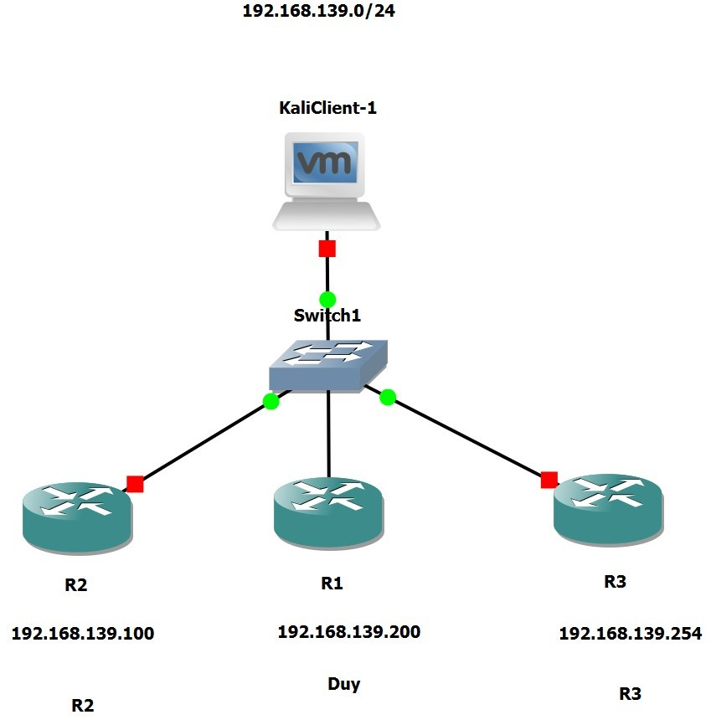

Figure 1: Basic Scenario Topology

Advanced Scenario
The advanced topology builds upon the basic setup by introducing a more intricate network environment designed to showcase Ansible’s capabilities in complex, multi-device scenarios. This topology includes:
- Three Cisco 3725 routers (R1, R2, R3) interconnected via a central switch (Switch1).
- A VPCS (Virtual PC) representing an end host on the network, allowing testing of end-to-end connectivity.
- A VMware Network Adapter (VMnet3) cloud, which bridges the GNS3 lab to the cloud which the cloud is assigned with virtual NIC in host machine.
This topology serves as a testbed for advanced Ansible automation tasks, such as:
- Deploying dynamic routing protocols across multiple routers.
- Automating complex interface settings.
- Demonstrating Ansible’s ability to manage multi-devices in a cohesive workflow.
- Advanced device inventory management.
The increased complexity provides a robust platform to validate Ansible’s scalability and flexibility in realistic network environments.

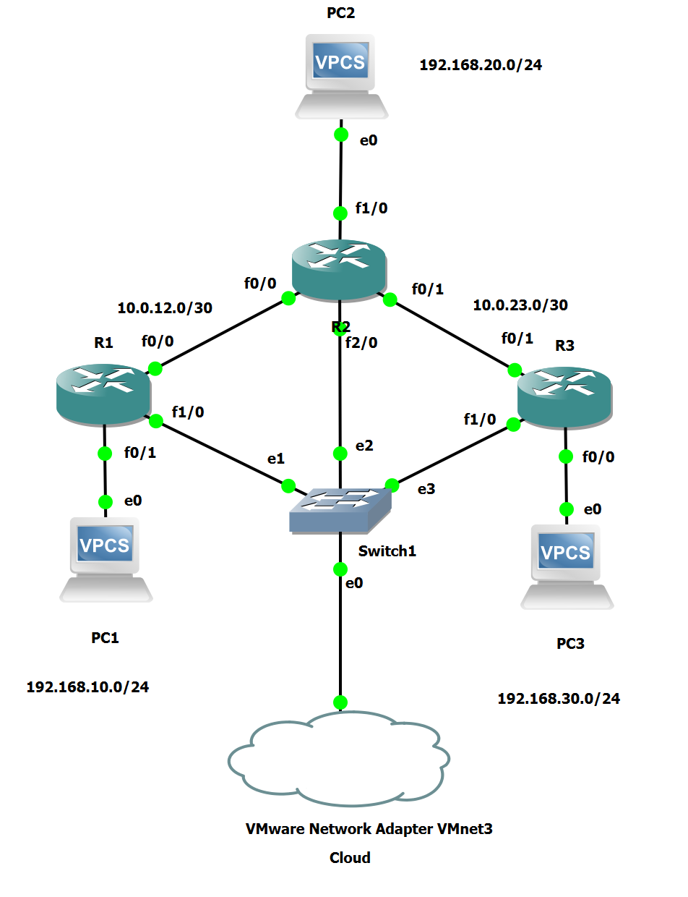
Figure 2: Advanced Scenario Topology

Installation

GNS3 installation
GNS3 installation involves several components that must be properly configured to work together:

GNS3 All-in-One Package: The GNS3 All-in-One installer provides the complete GNS3 environment including the GUI client, server components, and associated tools. The installation process includes:

- Download of the GNS3 version that easy to use that is GNS3 version from 2.2.x
Figure 3: GNS3 package installation
- Installation of Python dependencies and supporting libraries
- Setup of default preferences and resource allocation
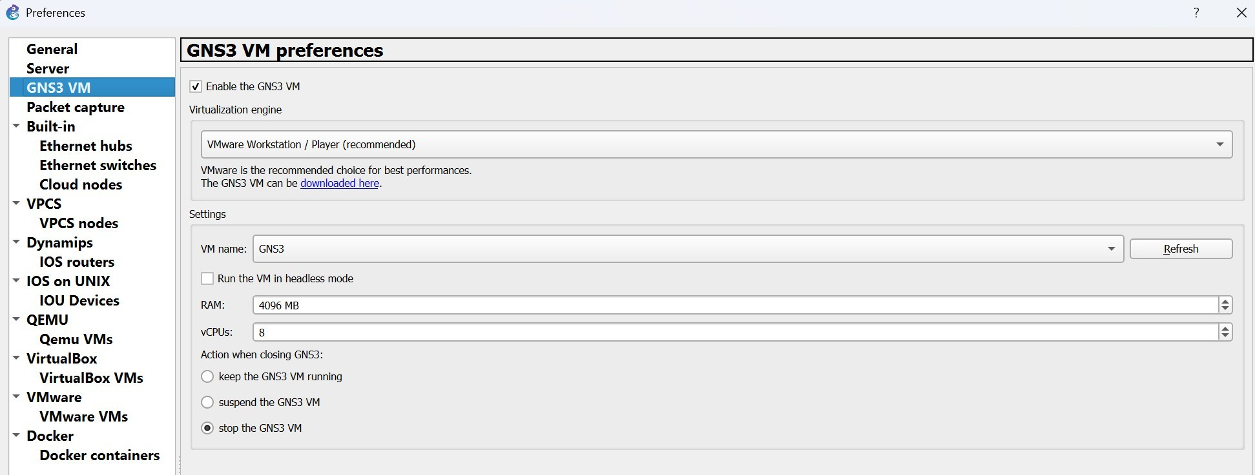
Figure 4: GNS3 preferences

GNS3 VM Setup: The GNS3 VM is crucial for proper device emulation and system stability:

- Download of the official GNS3 VM image (Ubuntu-based)

- Import into VMware Workstation or VirtualBox

- Resource allocation (minimum 2GB RAM, 4GB recommended)

- Network adapter configuration for host connectivity

- Virtual hardware optimization for emulation performance
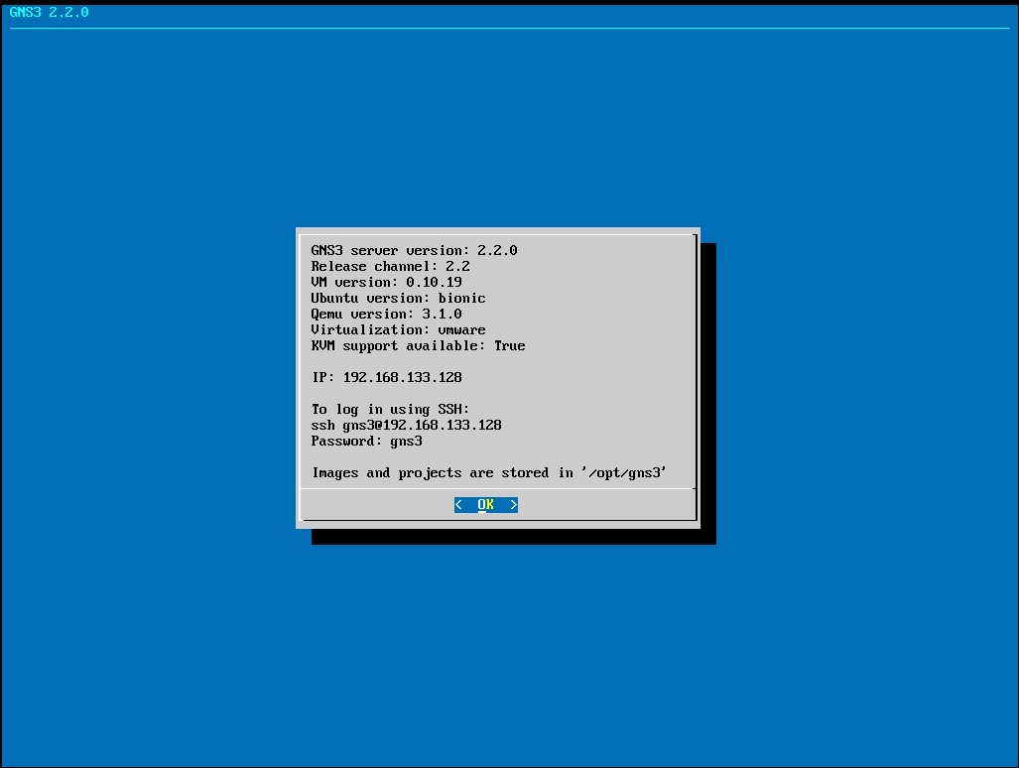
Figure 5: GNS3 VM
Device Image Installation: Network device images must be properly installed and configured:

- Cisco IOS images for router emulation

- Appliance templates for specialized devices

- VPCS for end-device simulation

Ansible installation
Ansible installation on the control host involves several key steps:
Package Installation: Ansible can be installed using various methods depending on the operating system:
- Package manager installation

- Python pip installation for latest versions

- Source compilation for custom requirements
Network Module Installation: Additional network-specific modules may be required:

- Cisco IOS modules for device management
- Generic network modules for multi-vendor support

- Custom modules for specialized functionality
- Module documentation and examples
SSH Configuration: Proper SSH setup is essential for Ansible connectivity:
- SSH key generation and distribution
- Known hosts configuration

- Connection timeout and retry settings

- Security considerations for lab environments
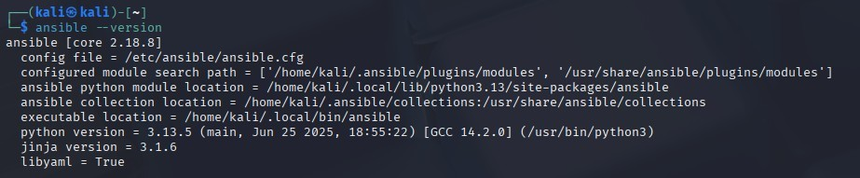

Figure 6: Ansible version

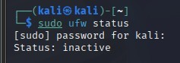

Figure 7: Firewall status
Figure 8: SSH configuration

Configuration

GNS3 configuration
Project Setup: GNS3 projects require proper organization and resource management:
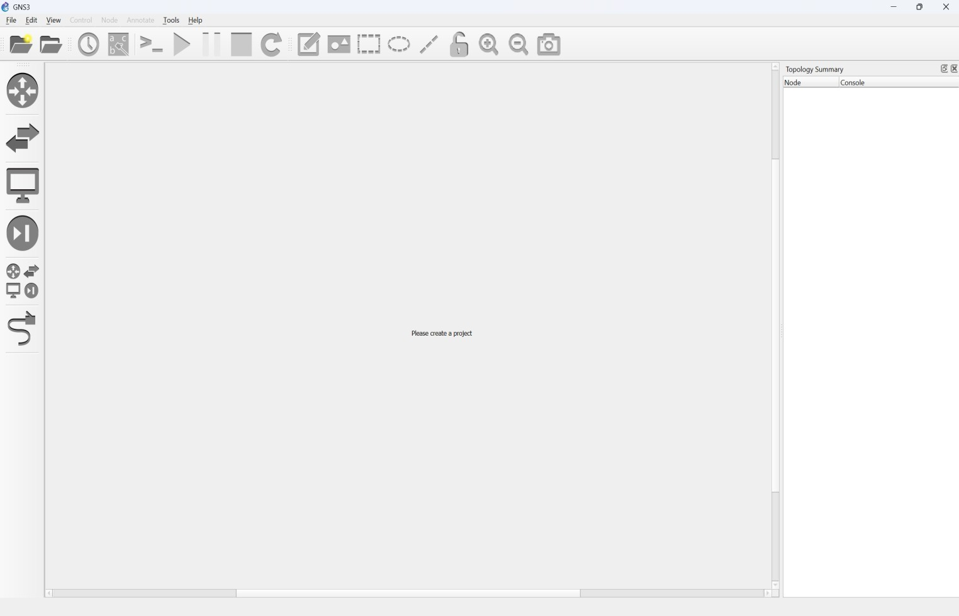
Figure 9: GNS3 GUI
  - Project creation with appropriate naming conventions

  - Network adapter configuration

  - Config GNS3 VM

Device Templates: Proper device templates ensure consistent deployment:

  - Router templates

  - Memory and slot configurations

  - Interface mapping and naming conventions
Network Configuration: GNS3 network settings must align with automation requirements:

  - Bridge configuration for host connectivity

  - VLAN setup for network segmentation

Ansible configuration
      - Basic scenario
Create inventory for the network devices that have in the basic topology
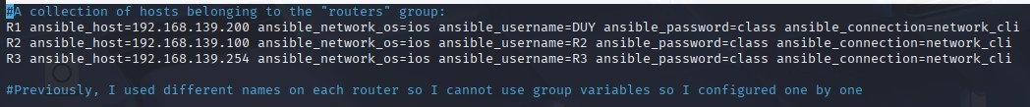
Figure 10: Basic inventory Create ansible yaml file to auto config basic scenario

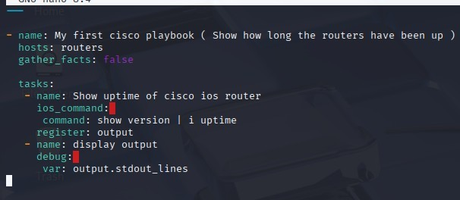
Figure 11: Baisc config
      - Advanced scenario
Create inventory for the network devices that have in the advanced topology
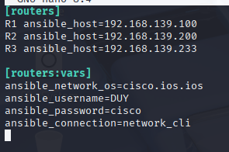
Figure 12: Advanced inventory
Create ansible yaml file to auto config advanced scenario
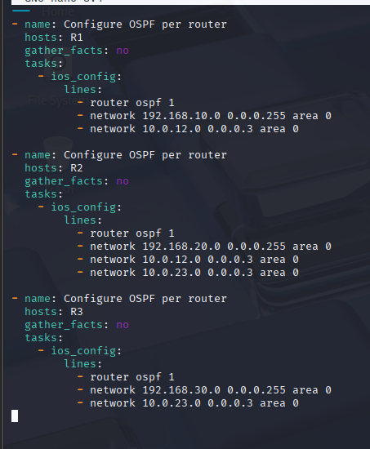

Figure 13: Advanced config

RESULT

Basic scenario
Config all network devices to allow ssh from kali host
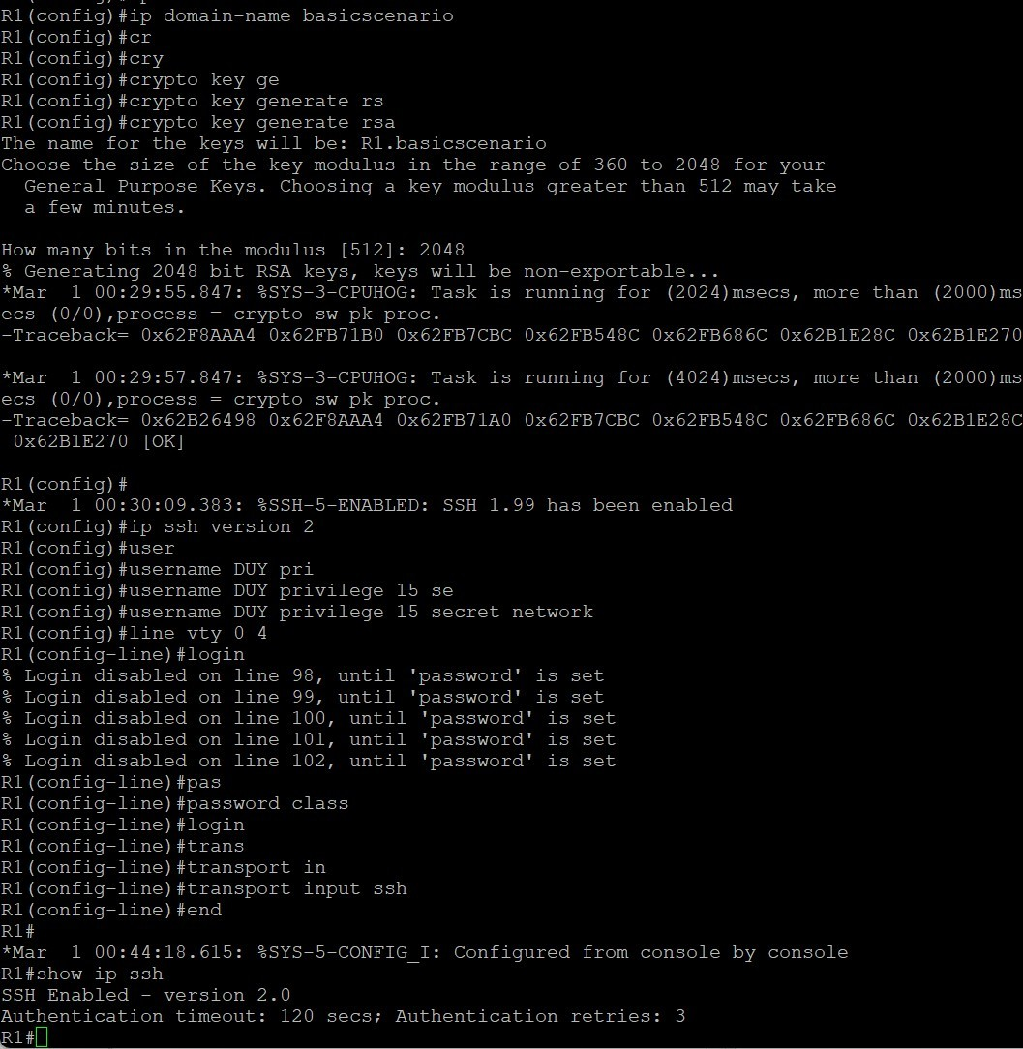
Figure 14: R1 configuration
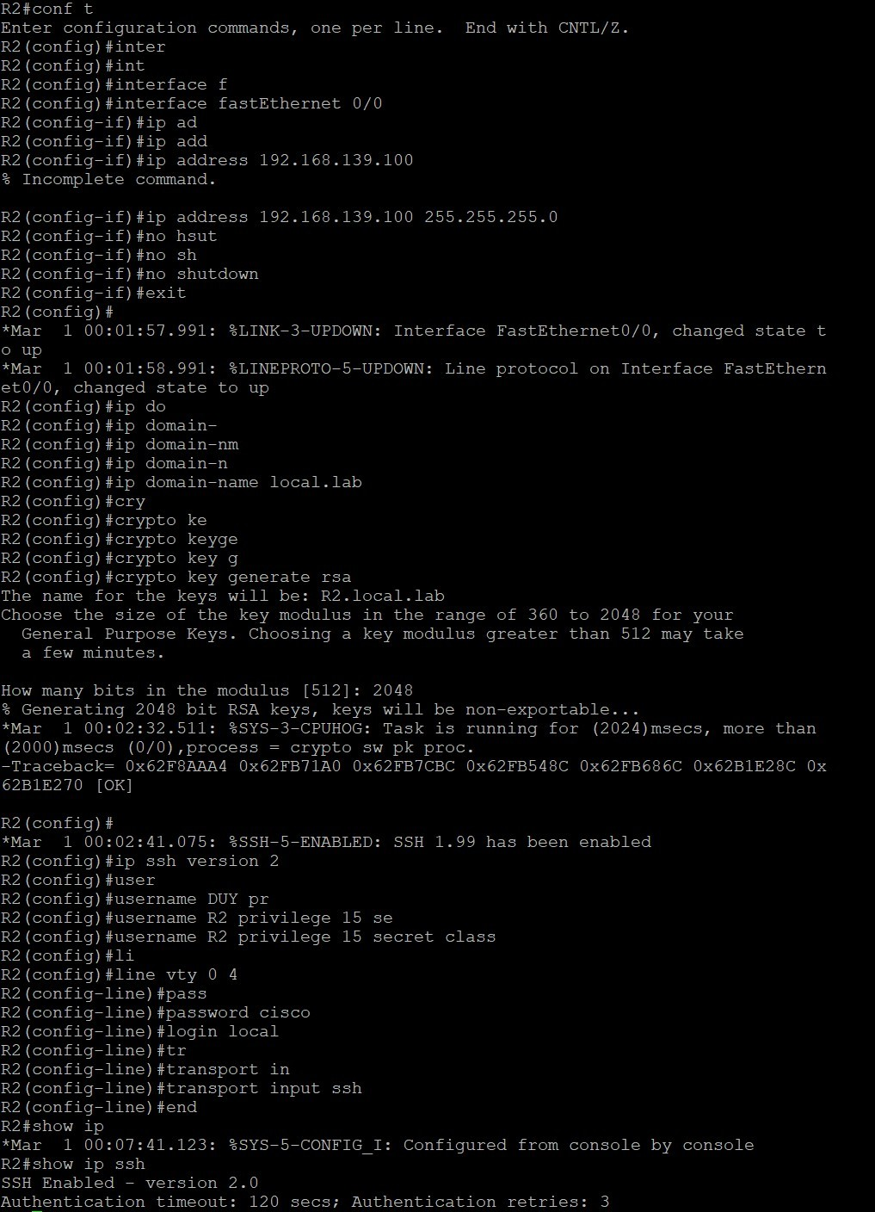
Figure 15: R2 configuration
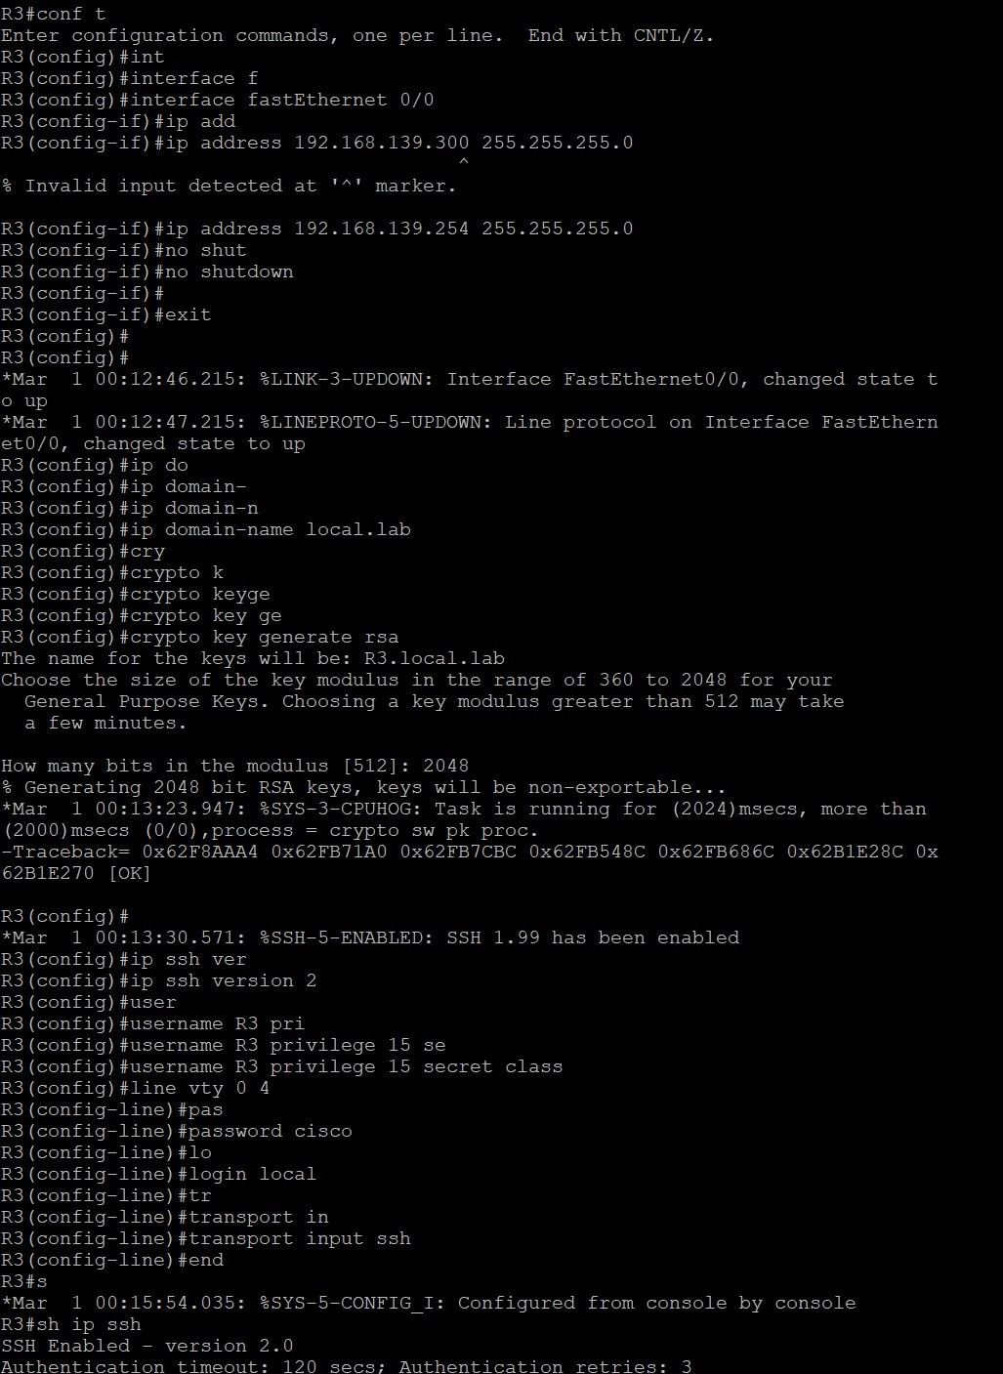
Figure 16: R3 configuration
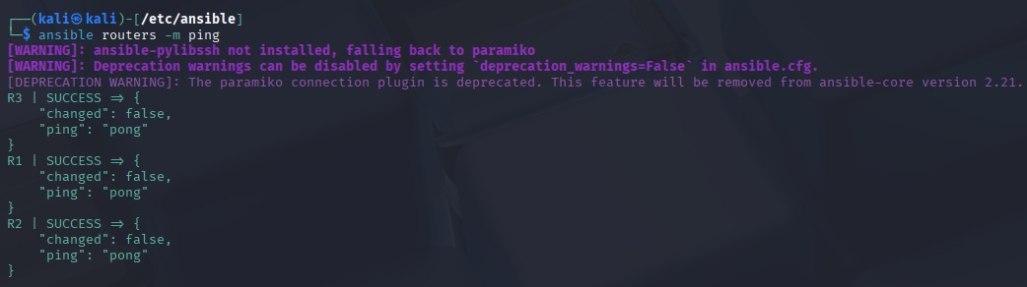
Figure 17: Test connectivity
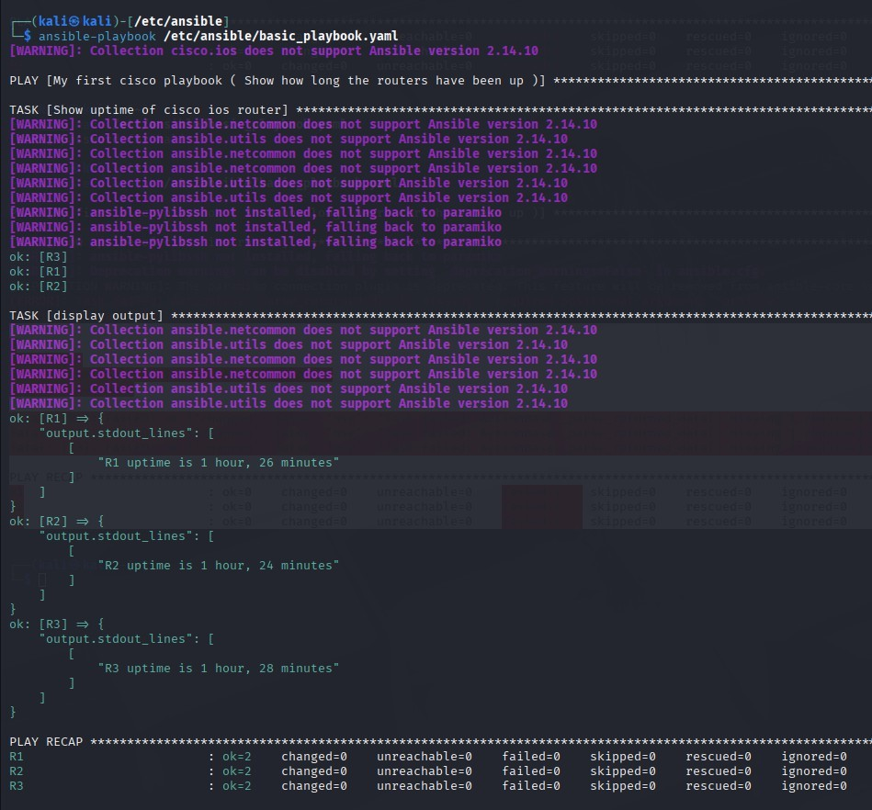
Figure 18: Run basic playbook
This basic scenario is used for understanding what is ansible, and how do it works, so it is really easy.

Advanced scenario
Config all routers in the topology
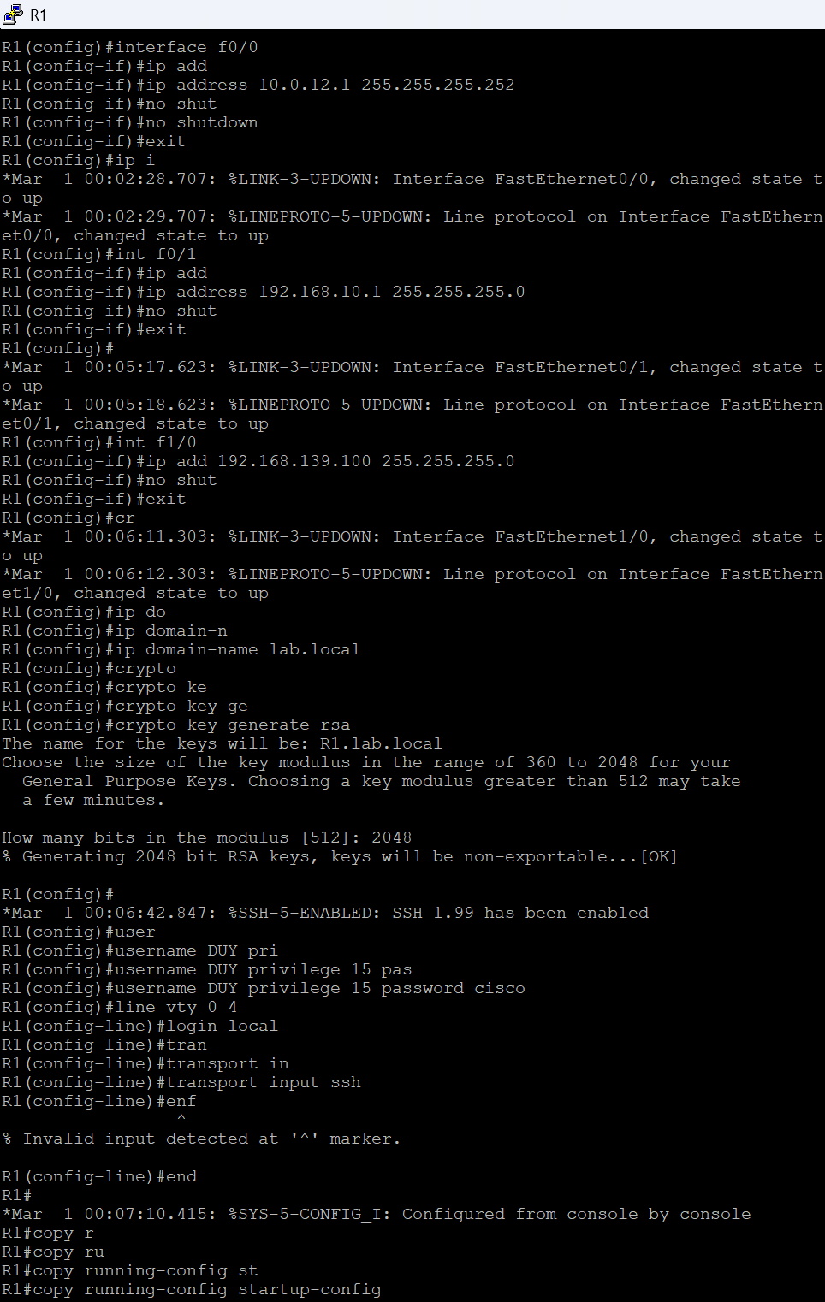

Figure 19: Advanced R1 configuration

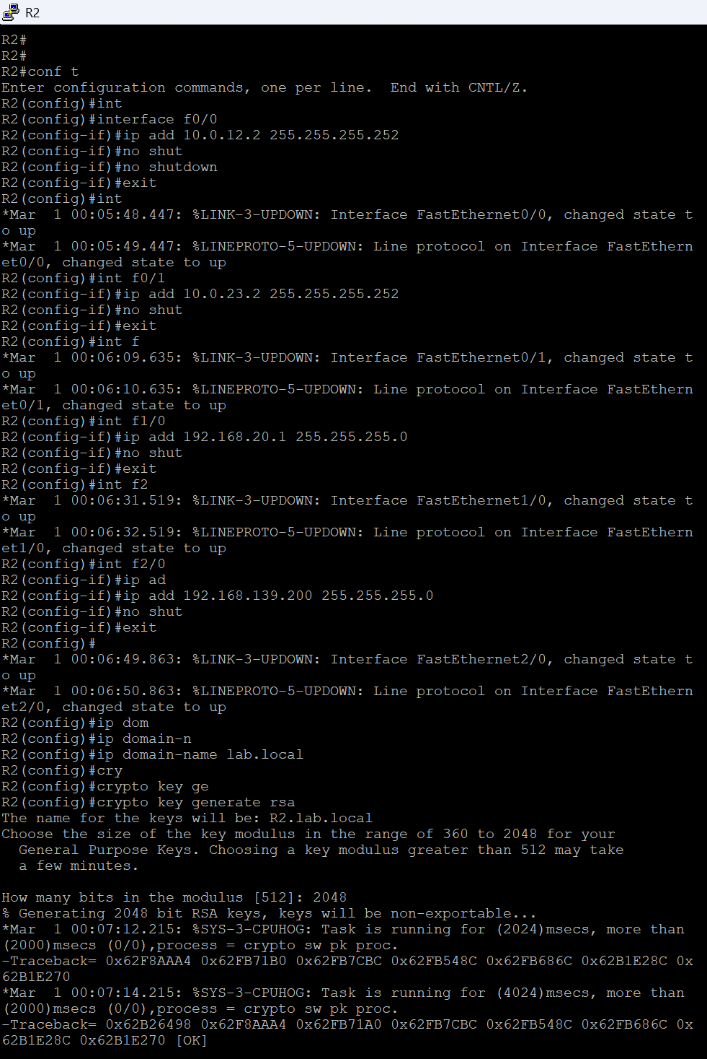

Figure 20: Advanced R2 configuration

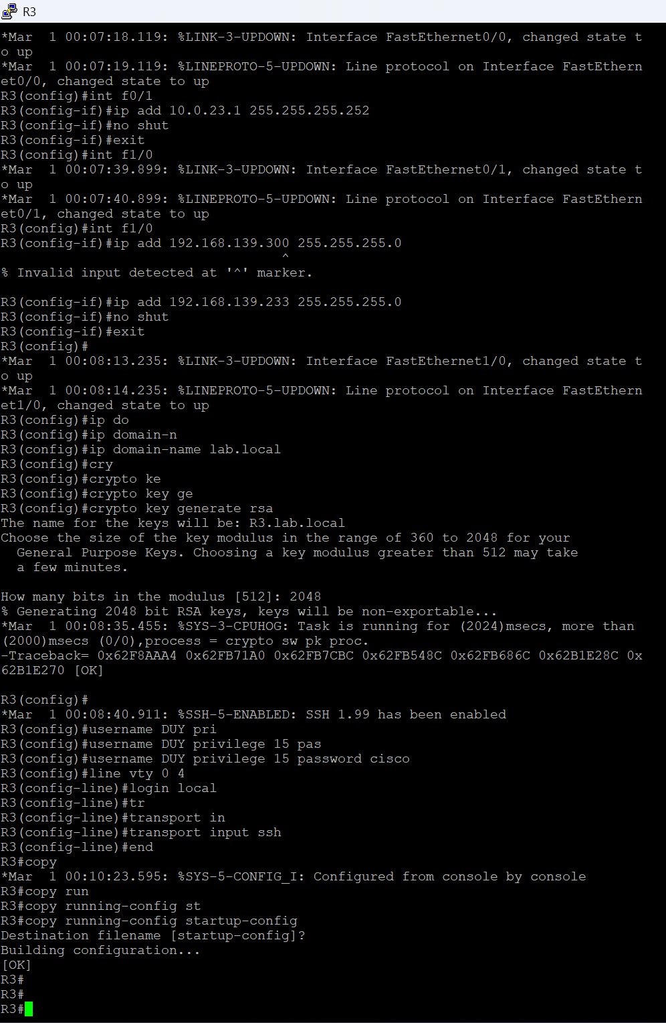

Figure 21: Advanced R3 configuration

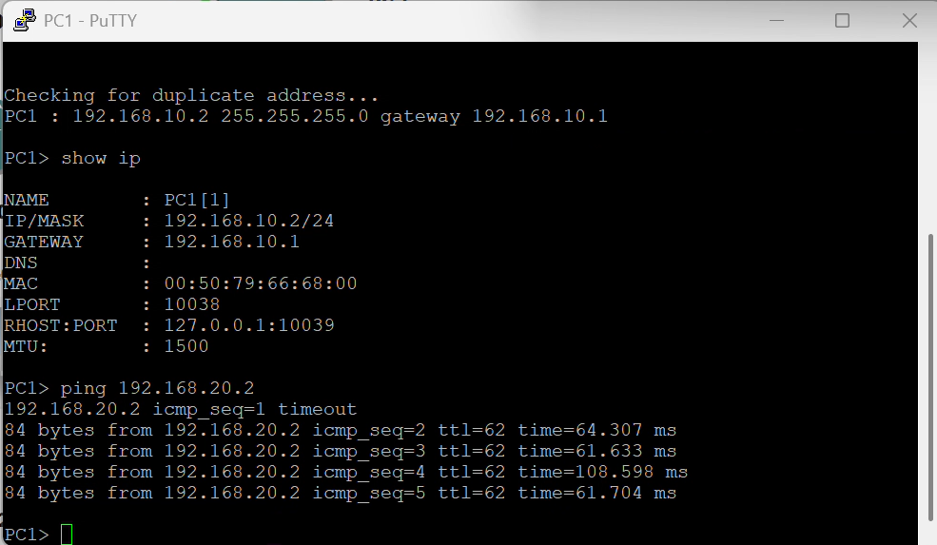

Figure 22: PC1 ping to PC2
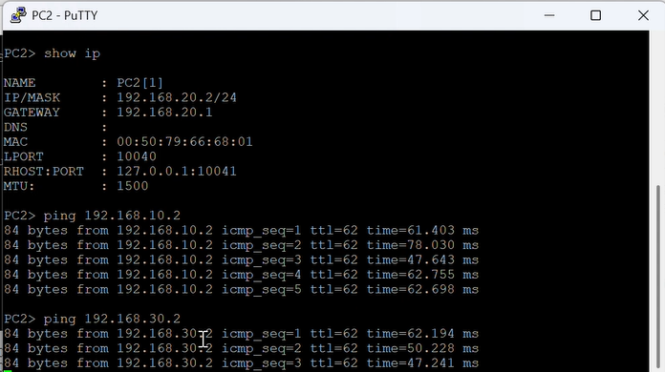

Figure 23: PC2 ping to PC3

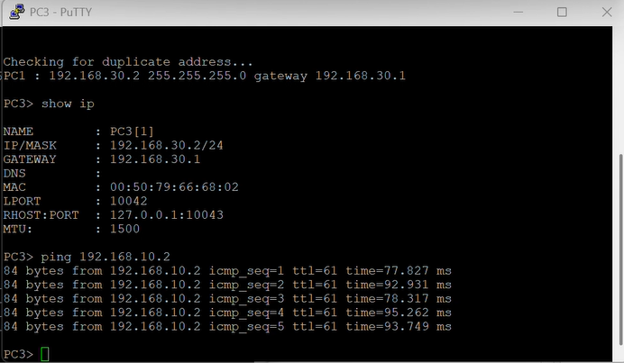

Figure 24: PC3 ping to PC1

This advanced scenario is used for understanding how ansible playbook works to configure the network devices and network protocols.

REFERENCES
- GNS3 Documentation. GNS3 VM Setup Wizard. Available at: https://docs.gns3.com/docs/getting- started/setup-wizard-gns3-vm/

- EVE-NG Documentation. EVE-NG Professional Edition Documentation. Available at: https://www.eve- ng.net/index.php/documentation/

- Red Hat Ansible Documentation. Ansible Documentation. Available at: https://docs.ansible.com/

- Ansible Network Automation Guide. Network Automation with Ansible. Available at: https://docs.ansible.com/ansible/latest/network/getting_started/index.html

